**SOFTWARE ENGINEERING LEC/LAB**

**MIDTERM EXAM**

**“REGISTER, LOGIN, LOGOUT AND WHO DID IT?”**

**NAME:Montemayor, Charles David A.**

**SECTION:UCOS 3-1**

**INSTRUCTIONS:**

* Go back to your activity, **YOUR BUSINESS IDEAS AS SEEN WITH PDO**, what you need to do for your midterm exam is to add a **USER ENTITY** to the system you created. The user should have columns storing his personal information. For example, a user may have the first_name, last_name, address, age, etc columns for the users table. No limits on the columns that need to be filled.
* The user should be able to **LOGIN, REGISTER, AND LOGOUT** from the system and keep in mind that we should be able to keep track of that certain user who made an insertion, deletion, and updating of a record stored in the database.
* For example if your chosen business is a web development, we should be able to **IDENTIFY THAT USER** who **CREATED** a project, **UPDATED** a project, and the **LAST TIMESTAMP** when the project was updated. So for your tables, you must add additional columns, added_by and last_updated.
* Please keep in mind that a user should **NOT BE ABLE** to access the homepage without logging in. If a user goes inside index.php and he’s not logged in, he should be redirected to the login page.
* Don’t forget to give what’s being asked from the items below.

1. How did you implement the **User entity** to the system you created? Give **the complete steps below** with some screenshots of the steps you took.

* First: I created a new table for the users, here is that table:

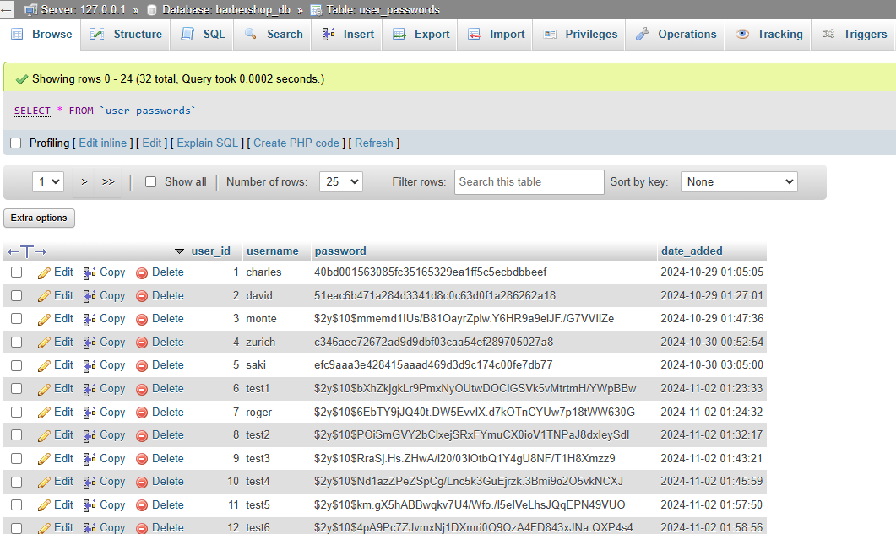

It contains the username and password that’s been hashed by the user and the date that it created.

* Second: We need to insert a user to the table (register) here how we insert a new user to the table:  
  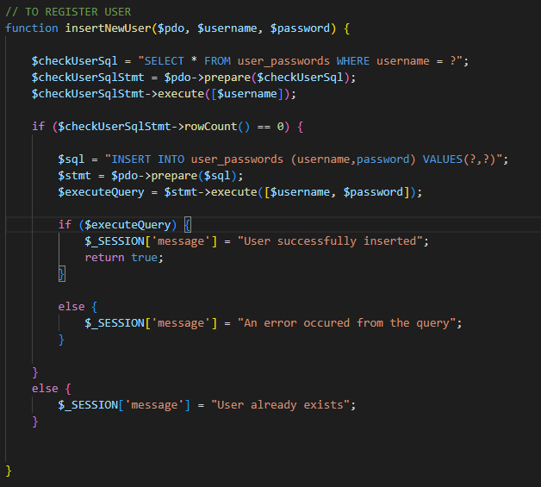
* Third: Once it is inserted to the table, we need to check if the username and password of the user in the login page has a match in the table we created in the first step(login) here is how we verify it:  
  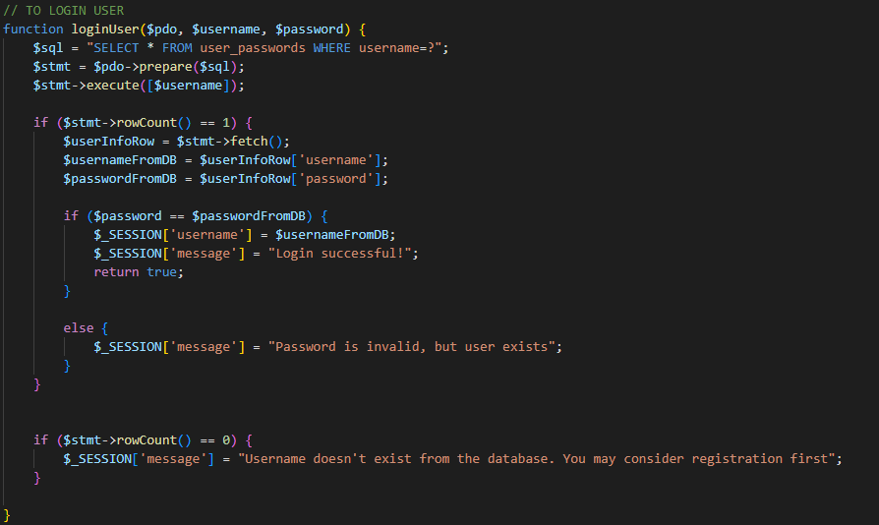
* So if there is a match found within the table it will proceed to the index file, each function above correspond a specific button to perform each action, and will allocate a file where it should proceed next.

1. Show a screen-recorded demonstration of the system you created and paste its **Google Drive link** below. This should include **registration**, **logging in**, **inserting**, **updating**, **deleting** records from the system and **logging out**. Don’t forget to set its visibility to **anyone with link.**

<https://drive.google.com/drive/folders/1jdk14x3pv7S80Vl_EKMT6CdPJggvf2F1?usp=sharing>

1. Paste **GitHub** link of project below.

<https://github.com/foshoo0/5_MIDTERM_EXAM_REGISTER_LOGIN_LOGOUT_AND_WHO_DID_IT->